Untitled

## [1] 306.0049

## [1] 3.468883

## [1] 261.9291

## [1] 1.891954

## [1] 299.1367

## [1] 1.467861

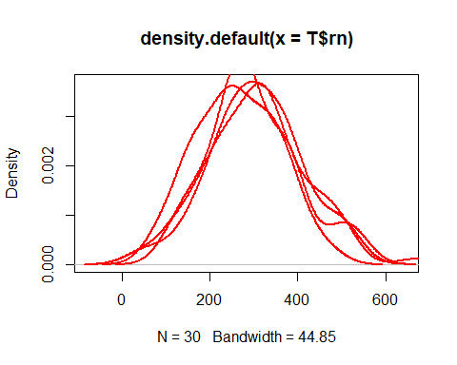

## [1] 303.748

## [1] 1.273547

Note that the echo = FALSE parameter was added to the code chunk to prevent printing of the R code that generated the plot.